This News Item was published yesterday – and **All Employees** was selected in error. The correct audience **is Branch management personal advice team** and **Head office employees**.

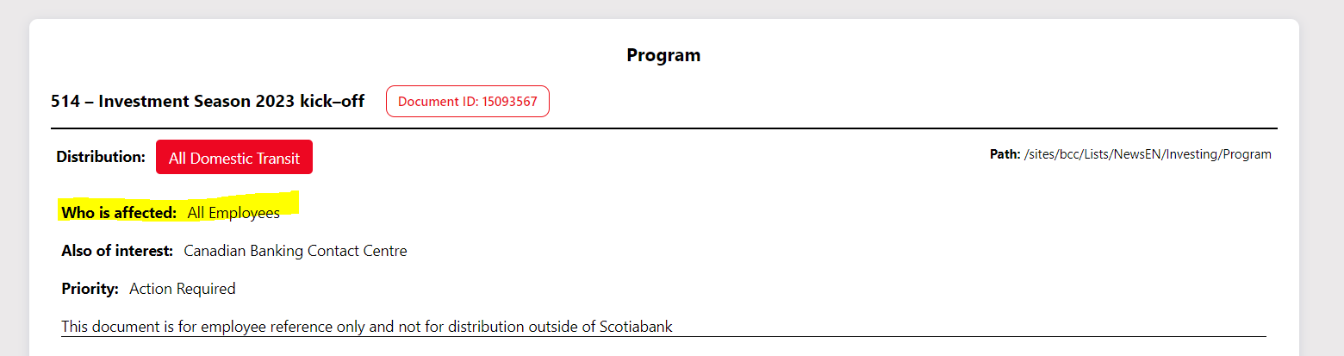

I updated it in SharePoint, but it previewed as All Employees and it published again as All employees. I cleared my cache and it makes no difference.

I just pulled it back into SharePoint per below, and my changes are there – but they are not reflected on IntraLink. The NI is back on the home page, but still as **All Employees**.

